 | 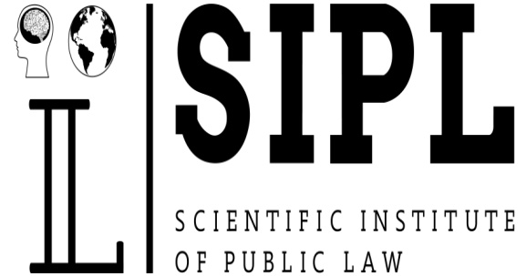

Dear colleagues!

Academy of Administrative Law
Research Institute of Public Law
together with:
V. M. Koretsky Institute of State and Law of the National Academy of Sciences of Ukraine;
School of Liberal Arts and Law, Guangdong University of Petrochemical Technology, Maoming (China);
Belt and Road Initiative Centre for Chinese-European studies (BRICCES), Maoming (China);

M. Narikbaev “KAZGUU” University, Nur-Sultan (Republic of Kazakhstan);
Greek-Catholic Theological Faculty of the University of Presov, Presov (Slovakia);

Kherson Economic and Law Institute;
Scientific Institute of Maritime and Space Law;
LLC Science & Space

Invite you to participate in the International Scientific and Practical Online-Conference "Current issues of administrative, maritime and space law in the context of counteraction to coronavirus disease (COVID-19)”.

The conference will be held on April 24, 2020. The purpose of this conference is to identify and summarize the philosophical and legal aspects of the preservation of the human race in the context of viral pandemics in space - on Earth, in the sea and outer space; to generalize the factors of public administration in the field of counteraction to spread of coronavirus disease (COVID-19); to highlight the strict administrative and legal regimes to combat COVID-19, as well as to reveal their impact on the restriction (violation) of citizens' rights and freedoms.
Scientists, lawyers, scientific and pedagogical specialists who teach administrative, maritime and space law, officials of public administration, judges, medical staff and others involved in countering COVID-19 are invited to participate in the scientific event.

The working languages of the conference:
Ukrainian, English, Russian.
The form of participation in the conference is remote.
Interested experts are requested no later than April 20, 2020 :
- to send an email to the organizing committee (arshm@ukr.net) containing:
• edited abstract (see sample and requirements);
• scanned recommendation of the academic advisor (for participants without a scientific degree);
- to fill in the registration form of the conference participant.

The following thematic areas of the conference are offered:
1. Philosophical and theoretical fundamentals of law and State.
2. Topical issues of administrative, maritime and space law.
3. Legal regimes and public administration in the field of counteraction to spread of coronavirus disease (COVID-19).
4. Administrative liability for breach of legislation on combating coronavirus.
5. Current problems of European law and comparative law.
6. Comparative characteristic of public administration in the field of counteraction to spread of coronavirus disease (COVID-19).
7. Fiscal and customs matters in the context of counteraction to coronavirus disease (COVID-19).
8. Legal support (restriction) of the economy in the context of counteraction to coronavirus disease (COVID-19).
9. Legal issues of maritime transportation in the context of counteraction to coronavirus disease (COVID-19).
10. Development of information technology and information law in the context of counteraction to coronavirus disease (COVID-19).
11. Topical issues of the judiciary in the light of judicial reform and proceedings in the context of counteraction to coronavirus disease (COVID-19).

For more details please contact: Research Institute of Public Law, Soroka Larysa Volodymyrivna, tel. +38 (098) 9255765

Official Website: http://sipl.com.ua/
vities, police, measures of legal protection.

